***Course No :*** CSE 204

***Course Title :*** Data structure and algorithm sessional

***Offline No :*** 1

***Title* :** Timecomparison between two search algorithms

***Submitted by :***

***Kawshik Kumar Paul***

***Student No :*** 1705043

***Level :*** 2 ***Term :*** 1

***Objective:***

Linear search and binary search are two searching algorithms. Though both of these algorithms are searching algorithms but they have different time complexities.

A Linear Search is the most basic type of searching algorithm. A Linear Search sequentially moves through your collection (or data structure) looking for a matching value. In other words, it looks down a list, one item at a time, without jumping. A Linear Search is starting at the beginning, reading every name until you find what you’re looking for. n complexity terms this is an O(n) search - the time taken to search the list, gets bigger at the same rate as the list does.

A binary search locates an item in a sorted array by repeatedly dividing the search interval in half. The initial interval includes the entire array. If the value of the search key is less than the item in the middle of the interval, then the next interval will be the lower half of the current interval. If the value of the search key is greater than the middle item, then the next interval will be the upper half. The search process repeats until the item is found or the search interval is empty. Binary Search is an O(log n) algorithm, which is more efficient than a linear search for large arrays.

***Machine configuration:***

Processor : Intel® Core™ i7-8500U CPU @ 1.80 GHz 1.99 GHz

Installed memory (RAM) : 8.00 GB (7.88 GB usable)

OS : Windows 10 Home (64 Bit)

Compiler : GNU GCC

***Dataset and Chart:***

***Here are some sample array size and their evaluation result.***

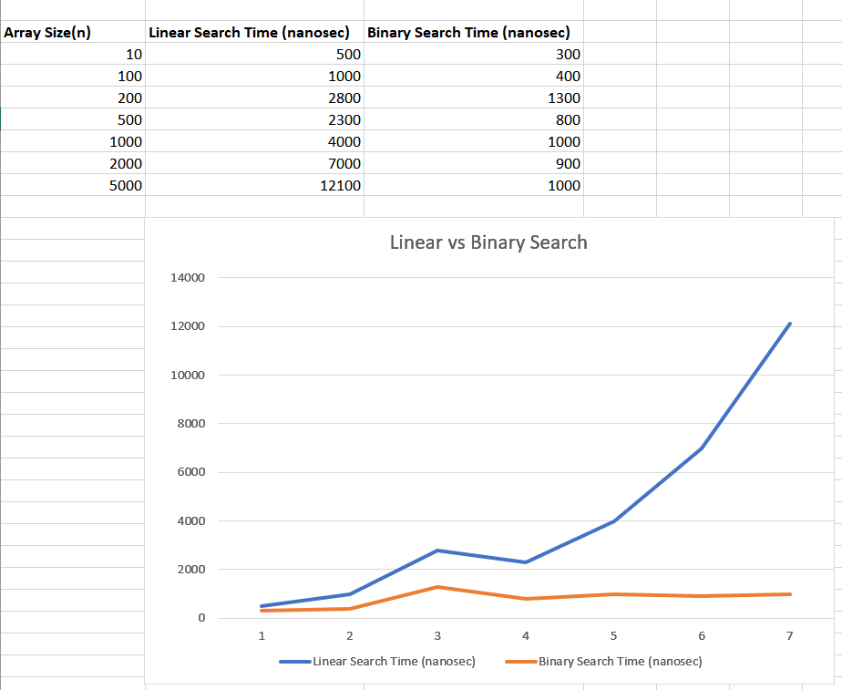

***Discussion:***

Linear search algorithm takes more time to find an element in an array than binary search. In worst case scenario, the compiler has to examine every single item of the array. The complexity will be O(n).

But binary search needs less time than linear searching. From the graph we can see this too. The array size varies from 10-1000. It is found that for the larger array size linear search time consistently increases and it takes a lot more time than binary search algorithm. But whatever array size is time needed for binary search does not increase too much. It gives almost a consistent line. So we can say that binary search is more effective than linear search in an sorted array.